Office of City Clerk
City Council Document Tracking Sheet
City Hall
121 North LaSalle Street Room 107
Chicago, IL 60602 www.chicityclerk.com

Matter ID: Meeting Date: Sponsor(s): Type:

10/4/2023
Johnson (Mayor) * Ordinance
02023-0005103

Title: Intergovernmental agreement with Chicago
Transit Authority for purchases of various City parcels and easements within several Tax Increment Financing Redevelopment Project Areas between S 95th St and S 130th St for the Red Line Extension Project
Committee Assignment: Committee on Committees and Rules

Office of the City Clerk Page 1 of 1 Report generated on 10/5/2023 5:27:30 PM

BRANDON JOHNSON
MAYOR
OFFICE OF THE MAYOR
CITY OF CHICAGO

October 4, 2023

TO THE HONORABLE, THE CITY COUNCIL OF THE CITY OF CHICAGO

Ladies and Gentlemen:

At the request of the Commissioner of Planning and Development, I transmit herewith an ordinance authorizing land disposition intergovernmental agreement with the Chicago Transit Authority for the Red Line Extension project.

Your favorable consideration of this ordinance will be appreciated.

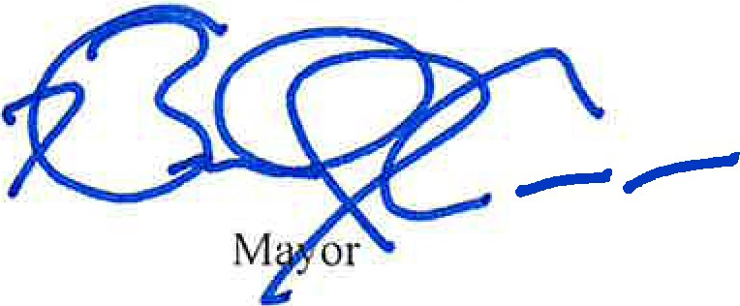
Very truly yours,

ORDINANCE

WHEREAS, the City of Chicago (the "City") is a home rule unit of government under Article VII, Section 6(a), of the 1970 Constitution of the State of Illinois, and, as such may exercise any power and perform any function pertaining to its government and affairs; and

WHEREAS, the Metropolitan Transit Authority Act, 70 ILCS 3605/1, et seq., created the Chicago Transit Authority (the "CTA") with the power to acquire, construct, own, operate and maintain for public service a transportation system in the metropolitan area of Cook County; and

WHEREAS, the CTA has a project, known as the "Red Line Extension Project", to extend its Red Line service from 95th Street to 130th Street ("RLE Project"); and

WHEREAS, on December 14, 2022, the City Council approved: (1) "An Ordinance of the City of Chicago, Illinois Designating a Transit Facility Improvement Area for the Red Line Extension (RLE) Project" (CJ pp. 57775-57777); (2) "An Ordinance of the City of Chicago, Illinois Approving a Redevelopment Plan for the Red Line Extension (RLE) Redevelopment Project Area" (CJ pp. 57525-57601); (3) "An Ordinance of the City of Chicago, Illinois Designating the Red Line Extension (RLE) Redevelopment Project Area as a Redevelopment Project Area Pursuant to the Tax Increment Allocation Redevelopment Act" (CJ pp. 57734- 57774); (4) "An Ordinance of the City of Chicago, Illinois Adopting Tax Increment Allocation Financing for the Red Line Extension (RLE) Redevelopment Project Area" (CJ pp. 57778-57817); and (5) "Intergovernmental Agreement with Chicago Transit Authority for Use of Tax Increment Financing Assistance Funds for Red Line Extension Project" (CJ pp. 57261-57356) (together the "Transit TIF Ordinances"); and

WHEREAS, the Transit TIF Ordinances establish a project area between 95th Street and 130th Street (the "RLE Project rea"); and

WHEREAS, the City owns land within the RLE Project Area, which is legally described in Exhibit A attached hereto (:Prope1ty"), that CTA needs for the RLE Project; and

WHEREAS, the CTA has submitted a proposal to the City's Department of Planning and Development to purchase the Property for One and Noll 00 Dollar ($1.00) per parcel, to support the RLE Project; and

WHEREAS, certain parcels of the Property are located within the boundaries of other Tax Increment Financing Redevelopment Project Areas, specifically: (i) the }19th/Halsted Redevelopment Project Area; (ii) the 107th/Halsted Project Area; (iii) the Roseland/Michigan Avenue Redevelopment Project Area; (iv) the Lake Calumet Industrial Redevelopment Project Area; and (v) the 105th Street and Vincennes Avenue Redevelopment Project Area ("Redevelopment Areas '); and

WHEREAS, by Resolution No. 23-CDC-33, adopted on August 8, 2023, the Community Development Commission ("CDC") recommended the conveyance of the Property for the RLE Project as consistent with the respective Redevelopment Plans for each of those Redevelopment Areas; and

WHEREAS, the CTA's Board of Directors, pursuant to a resolution adopted on September 22,_2023, approved the acquisition of the Property for the purpose of the RLE Project; and

WHEREAS, by Resolution No. 23-035-21, adopted on September 21, 2023, the Chicago Plan Commission approved the disposition of the Property; and

WHEREAS, supporting the RLE Project is related to the government and affairs of the
City.

NOW, THEREFORE, BE IT ORDAINED BY THE CITY COUNCIL OF THE CITY OF CHICAGO:

SECTION 1. The foregoing recitals are hereby incorporated by reference and made a part
hereof.

SECTION 2. The Commissioner of the Planning and Development ("Commissioner of DPD"), or a designee of the Commissioner of DPD, is hereby authorized, with the approval of the City's Corporation Counsel as to form and legality, to execute an intergovernmental agreement with CTA substantially in the form of exhibit B which is attached and incorporated ("IGA").

SECTION 3. The Mayor or his proxy is authorized to execute, and the City Clerk or Deputy City Clerk is authorized to attest, one or more quitclaim deed(s) conveying portions of the Property to the CTA, in accordance with the IGA.

SECTION 4. The Commissioner of DPD is authorized to take all actions and, subject to the approval of the Corporation Counsel as to form and legality, execute all agreements, which are necessary or appropriate for implementation of the IGA and the intention of this ordinance, including the execution of the permanent easement referenced in the IGA, subject to approval of Commissioner of Assets, Information and Services ("Commissioner of DAIS"). Further, the Commissioner of DPD is authorized to designate any City owned or controlled property for inclusion in the temporary easement in accordance with the IGA.

SECTION 5. If any provision of this ordinance shall be held to be invalid or unenforceable for any reason, the invalidity or unenforceability of such provision shall not affect any of the other provisions of this ordinance.

SECTION 6. All ordinances, resolutions, motions, or orders in conflict with this ordinance are hereby repealed to the extent of such conflict.

SECTION 7. This ordinance shall be in full force and effect immediately upon its passage and approval.

Attachments: Exhibit A Exhibit B

Legal Description of Property Form ofIGA

