Office of City Clerk
City Council Document Tracking Sheet
City Hall
121 North LaSalle Street Room 107
Chicago, IL 60602 www.chicityclerk.com

Matter ID: Meeting Date: Sponsor(s): Type:

9/13/2023
Johnson (Mayor) *

Ordinance
02023-0004234

Title:
Negotiated Sale of City-owned property improved with former firehouse at 2358 S Whipple St to National Museum of Mexican Art conditioned on execution of redevelopment agreement to establish community center for art

Committee Assignment: Committee on Housing and Real Estate

Office of the City Clerk Page 1 of 1 Report generated on 9/14/2023 2:12:58 PM

BRANDON JOHNSON
MAYOR
OFFICE OF THE MAYOR
CITY OF CHICAGO

September 14, 2023

TO THE HONORABLE, THE CITY COUNCIL OF THE CITY OF CHICAGO

Ladies and Gentlemen:

At the request of the Commissioner of Planning and Development, l transmit herewith ordinances authorizing the negotiated sale of City-owned properties.

Your favorable consideration of these ordinances will be appreciated.

Very truly yours,
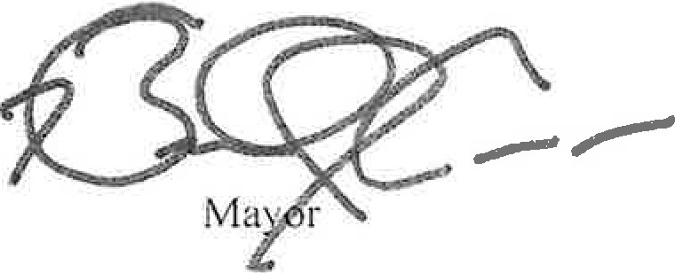

ORDINANCE

WHEREAS, the City of Chicago ("City") is a home rule unit of government by virtue of the provisions of the Constitution of the State of Illinois of 1970, and, as such, may exercise any power and perform any function pertaining to its government and affairs; and

WHEREAS, the City is the owner of the real property located at 2358 S. Whipple Street, Chicago, Illinois, as legally described on Exhibit A attached hereto (the "Property"), which consists of approximately 6,895 square feet of land and is improved with a vacant fire station of approximately 8,648 square feet; and

WHEREAS, National Museum of Mexican Art, an Illinois not-for-profit corporation (the "Developer''), has submitted a proposal to the Department of Planning and Development (the "Department") for the sum of One Dollar ($1.00) (the "Purchase Price") for the purchase and adaptive reuse of the Property; and

WHEREAS, the Developer intends to use the Property as a community center for art programming; and

WHEREAS, the appraised fair market value of the Property as of October 19, 2022, is Twenty-Nine Thousand Dollars ($29,000.00); and

WHEREAS, by Resolution No. 23-026-021, adopted on July 20, 2023, the Chicago Plan Commission recommended the disposition of the Property to the Developer; and

WHEREAS, public notices advertising the Department's intent to enter into a negotiated sale of the Property with the Developer and requesting alternative proposals appeared in the Chicago Tribune, a newspaper of general circulation, on May 5, 12 and 19, 2023; and

WHEREAS, no alternative proposals were received by the deadline indicated in the aforesaid notices; now, therefore,

BE IT ORDAINED BY THE CITY COUNCIL OF THE CITY OF CHICAGO:

SECTION 1. The foregoing recitals are hereby adopted as the findings of the City Council.

SECTION 2. The City Council hereby approves the sale of the Property to the Developer or a Developer Entity (as defined below) for the Purchase Price. This approval is expressly conditioned upon the City entering into a redevelopment agreement with the Developer or the Developer Entity substantially in the form attached hereto as Exhibit B (the "Redevelopment Agreement''). The Commissioner of the Department (the "Commissioner"), or a designee of the Commissioner, is each hereby authorized, with the approval of the City's Corporation Counsel as to form and legality, to negotiate, execute and deliver the Redevelopment Agreement, with such changes, deletions and insertions as shall be approved by the Commissioner, and such other supporting documents as may be necessary or appropriate to carry out and comply with the provisions of this ordinance and the Redevelopment Agreement, including but not limited to indemnification, releases, affidavits and other documents to remove exceptions from title.

SECTION 3. The Mayor or the Mayor's proxy is authorized to execute, and the City Clerk or the Deputy City Clerk is authorized to attest, one or more quitclaim deed(s) conveying the Property to the Developer, or to a land trust of which the Developer is the sole beneficiary, or to an

entity of which the Developer is the sole controlling party, or to an entity which is comprised of the same principal parties (each, a "Developer Entity"), subject to those covenants, conditions and restrictions set forth in the Redevelopment Agreement.

SECTION 4. If any provision of this ordinance shall be held to be invalid or unenforceable for any reason, the invalidity or unenforceability of such provision shall not affect any of the other provisions of this ordinance.

SECTION 5. All ordinances, resolutions, motions or orders in conflict with this ordinance are hereby superseded to the extent of such conflict.

SECTION 6. This ordinance shall take effect upon its passage and approval.

Attachments: Exhibit A - Legal Description of Property Exhibit B - Redevelopment Agreement

