Committee on Pedestrian & Traffic Safety
July 10, 2024
City Council Meeting
DIRECT INTRODUCTION

MEMORANDUM FOR TRAFFIC REGULATIONS

PROHIBITION AGAINST PARKING (EXCEPT FOR THE DISABLED):

Applicant Name: Christ Granias

Primary Street Address: 5407 N. Virginia Ave.

Location to post signs: 5407 N. Virginia Ave.

Permit Number: 131673

Hours: At All Times

Days: No Exceptions

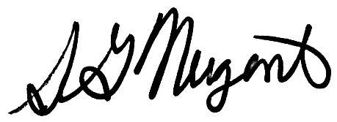
___________________________
SAMANTHA NUGENT
Alderman, 39th Ward

