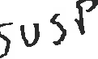

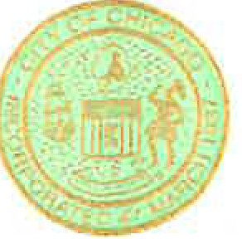

BRANDON JOHNSON
MAYOR
OFFICE OF THE MAYOR
CITY OF CHICAGO

November 1, 2023

TO THE HONORABLE, THE CITY COUNCIL OF THE CITY OF CHICAGO

Ladies and Gentlemen:

I transmit herewith, together with Aldermen Fuentes, Manaa-Hoppenworth, Gutierrez, Vasquez, Waguespack, Mitts, Ervin, Moore, Lopez, La Spata, Lawson, Hadden, Gardiner, Villegas, Nugent, Scott, O'Shea, Conway, Sposato, Martin, Robinson, Dowell, Silverstein, Ramirez-Rosa and City Clerk Valencia, a resolution celebrating Native American Heritage Month in Chicago.

Your favorable consideration of this ordinance will be appreciated.

