Office of City Clerk

City Council Document Tracking Sheet
City Hall
121 North LaSalle Street Room 107
Chicago, IL 60602 www.chicityclerk.com

Matter ID:

Meeting Date: 9/13/2023

Sponsor(s): Johnson (Mayor)*

Type: Ordinance

02023-0004129

Title: Sale of vacant City-owned property at 7507 S May St to Zachary Jones under Adjacent Neighbors Land Acquisition Program
Committee Assignment: Committee on Housing and Real Estate

Office of the City Clerk Page 1 of 1 Report generated on 9/12/2023 3:58:06 PM

BRANDON JOHNSON
MAYOR
OFFICE OF THE MAYOR
CITY OF CHICAGO

September 14, 2023

TO THE HONORABLE, THE CITY COUNCIL OF THE CITY OF CHICAGO

Ladies and Gentlemen:

At the request of the Commissioner of Planning and Development, I transmit herewith ordinances authorizing the sale of City-owned properties under the Adjacent Neighbors Land Acquisition Program.

Your favorable consideration of these ordinances will be appreciated.

Very truly yours,
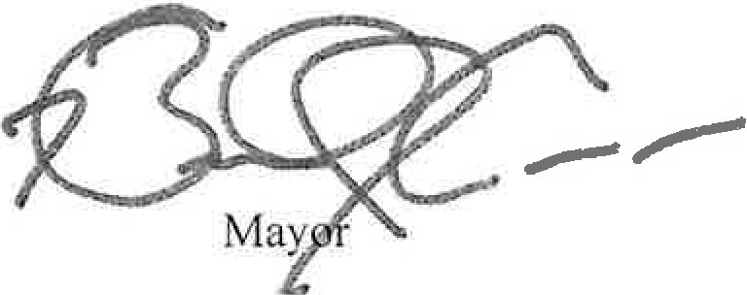

HSG-

BRANDON JOHNSON
MAYOR
OFFICE OF THE MAYOR
CITY OF CHICAGO

September 14, 2023

TO THE HONORABLE, THE CITY COUNCIL OF THE CITY OF CHICAGO

Ladies and Gentlemen:

At the request of the Commissioner of Planning and Development, I transmit herewith ordinances authorizing the sale of City-owned properties under the Adjacent Neighbors Land Acquisition Program.

Your favorable consideration of these ordinances will be appreciated.

Very truly yours,
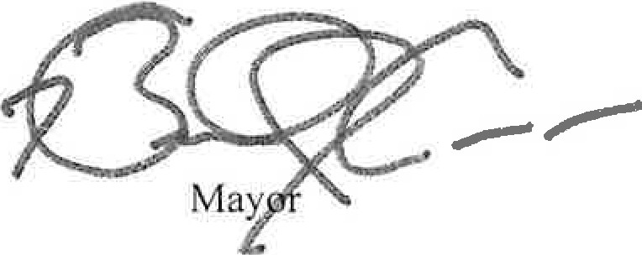

ORDINANCE

WHEREAS, the City of Chicago ("City") is a home rule unit of government by virtue of the provisions of the Constitution of the State of Illinois of 1970, and, as such, may exercise any power and perform any function pertaining to its government and affairs; and

WHEREAS, the City, through the foreclosure of demolition liens, tax sales and other methods of acquisition, has acquired title to numerous parcels of real property which are of minimal value and costly to clean up and maintain, and because title to such properties is vested in the City, the properties were exempted from real estate taxes, thus depriving the City of revenue; and

WHEREAS, pursuant to an ordinance (the "Original Program Ordinance") adopted by the City Council of the City ("City Council") on March 6, 1981 and published on pages 5584 - 5585 of the Journal of Proceedings of the City Council ("Journal") for such date, the City established a program for the disposition of certain vacant real property owned by the City known as the Adjacent Neighbors Land Acquisition Program; and

WHEREAS, the Original Program Ordinance was amended by ordinances adopted on July 23, 1982 and published in the Journal for such date at pages 11830 - 11833, and on January 7, 1983 and published in the Journal for such date at pages 14803 - 14805 (the Original Program Ordinance and such two amending ordinances, collectively, the "Original ANLAP Ordinances"); and

WHEREAS, pursuant to an ordinance adopted by the City Council on September 14, 1994 and published in the Journal for such date at pages 56195 - 56198, the City Council repealed the Original ANLAP Ordinances, and established a new program, also known as the Adjacent Neighbors Land Acquisition Program, for the disposition of certain vacant real property owned by the City, which ordinance was subsequently amended by ordinances adopted on September 4, 2002 and published in the Journal for such date at pages 92771 - 92773, and on July 28, 2010 and published in the Journal for such date at pages 97370 - 97374, and on June 25, 2014 and published in the Journal for such date at pages 83533 - 83535 (such new program, as amended, the "ANLAP Program"); and

WHEREAS, pursuant to the current ANLAP Program, as codified at Municipal Code Chapter 2-159-010 et seq. (the "ANLAP Program Ordinance"), a qualified City-owned parcel may be sold if it has an appraised value of not more than Fifty Thousand Dollars ($50,000); and

WHEREAS, pursuant to the ANLAP Program: (i) if the property appraises at or for less than Ten Thousand Dollars ($10,000.00) the minimum acceptable bid must be at least One Thousand Dollars ($1,000.00); or (ii) if the property appraises at or for less than Twenty Thousand Dollars ($20,000.00) but more than Ten Thousand Dollars ($10,000.00) the minimum acceptable bid must be at least Two Thousand Dollars ($2,000.00); or (iii) if the property appraises for more than Twenty Thousand Dollars ($20,000.00) the minimum acceptable bid must be Two Thousand Dollars ($2,000.00), plus fifty percent (50%) of the appraised value which exceeds Twenty Thousand Dollars ($20,000.00); and

WHEREAS, pursuant to the ANLAP Program, an Adjacent Neighbor means a person who owns one parcel, or two or more contiguous parcels, of real property that is immediately

adjacent to a city-owned parcel and at least one of the parcels is an improved parcel which the person occupies as his primary residence; and

WHEREAS, pursuant to the ANLAP Program, any deed conveying a parcel pursuant thereto shall contain covenants which: (1) prohibit the grantee from conveying, assigning or otherwise transferring the parcel except in conjunction with the sale of the real estate on which grantee's primary residence is located; and (2) require that the parcel be improved with landscaped open space within six (6) months of the conveyance of such parcel and prohibit the construction of any permanent improvements on the parcel, excluding only improvements made by the grantee on the parcel that constitute an integrated addition to the grantee's primary residence, or a garage appurtenant thereto; and (3) require the grantee to maintain the parcel in accordance with the provisions of the Municipal Code of Chicago. The covenants shall terminate ten (10) years after the date of the conveyance of the parcel to the grantee; and

WHEREAS, the Department of Planning and Development ("DPD") desires to convey the vacant parcel of real property identified on Exhibit A to this ordinance (the "ANLAP Parcel") to the Purchaser identified on Exhibit A hereto; and

WHEREAS, DPD has caused notice of the proposed sale of the ANLAP Parcel to be sent to all eligible adjacent neighbors (if any); and

WHEREAS, Purchaser's proposal was the highest (or only) ANLAP bid received by DPD;
and

WHEREAS, by Resolution Number 23-025-21 adopted on July 20, 2023, the Chicago Plan Commission approved the sale of the ANLAP Parcel to the Purchaser; now, therefore

BE IT ORDAINED BY THE CITY COUNCIL OF THE CITY OF CHICAGO:

SECTION 1. The City hereby accepts the bid of the Purchaser to purchase the ANLAP Parcel, which purchase shall be subject to all of the terms, conditions, covenants and restrictions of the ANLAP Program and the ANLAP Program Ordinance.

SECTION 2. The Mayor or the Mayor's proxy is authorized to execute, and the City Clerk or Deputy City Clerk is authorized to attest, a quitclaim deed conveying the ANLAP Parcel to the Purchaser for the purchase price of $1,000.00. Such deed shall include a covenant obligating the Purchaser to use the ANLAP Parcel only for a use consistent with the land uses permitted under the redevelopment plan for the Area and consistent with the requirements of the ANLAP Program Ordinance.

SECTION 3. The Commissioner of DPD (the "Commissioner''), or a designee of the Commissioner, is each hereby authorized, with the approval of the City's Corporation Counsel as to form and legality, to negotiate, execute and deliver such documents as may be necessary or appropriate to carry out and comply with the provisions of this ordinance, with such changes, deletions and insertions as shall be approved by the Commissioner or the Commissioner's designee. Such documents may contain terms and provisions that the Commissioner or the Commissioner's designee deems appropriate, including indemnification, releases, affidavits and other documents as may be reasonably necessary to remove exceptions from title with respect

....

to the Property or otherwise may be reasonably necessary or appropriate to consummate the transaction contemplated hereby.

SECTION 4. If any provision of this ordinance shall be held to be invalid or unenforceable for any reason, the invalidity of such provision shall not affect any of the other provisions of this ordinance.

SECTION 5. All ordinances, resolutions, motions or orders inconsistent with this ordinance are hereby repealed to the extent of such conflict.

SECTION 6. This ordinance shall take effect upon its passage and approval.

