Resolution
WHEREAS, We, the members of the Chicago City Council, wish to extend our congratulations and warmest wishes to Elmwood Funeral Chapel in honor of their 35th Year Commemoration; and

WHEREAS, on behalf of the entire 10th Ward, Alderman Peter Chico would like to extend his personal tribute to Elmwood Funeral Chapel on this momentous occasion as recognition for being a stellar funeral home in the City of Chicago; and

WHEREAS, Elmwood Funeral Chapel has been an outstanding leader in our community taking care of all our loved ones in our time of need. The Betkowski family remains committed to their bedrock principles of family, respect, honor, professionalism, and compassion, for 35 Years; and

BE IT RESOLVED, that we, the Mayor and members of the Chicago City Council, gathered here this 17th of April 2024, do hereby congratulate Elmwood Funeral Chapel on their 35th Year Commemoration; and

BE IT FURTHER RESOLVED, that we extend our most heartfelt wishes to Elmwood Funeral Chapel for their outstanding performance, compassion & success following their, 35thYear Commemoration; and

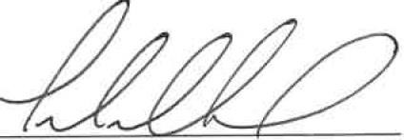
BE IT FURTHER RESOLVED, that a suitable copy of this resolution be presented to Elwood Funeral Chapel on their 35th Year Commemoration as a token of our esteem and good wishes.

Peter Chico Alderman, 10th Ward

