BRANDON JOHNSON
MAYOR

OFFICE OF THE MAYOR
CITY OF CHICAGO

November I, 2023

TO THE HONORABLE, THE CITY COUNCIL OF THE CITY OF CHICAGO

Ladies and Gentlemen:

At the request of the Commissioner of Planning and Development, I transmit herewith an ordinance authorizing the execution of an intergovernmental agreement with the Chicago Board of Education to provide TIF funds for improvements at Kenwood Academy High School.

Your favorable consideration of this ordinance will be appreciated.

Very truly yours,
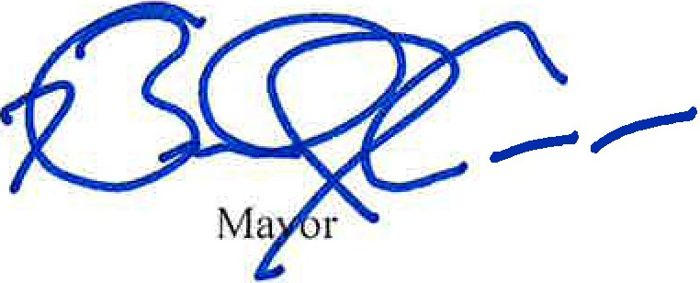

ORDINANCE

WHEREAS, the City of Chicago {the "City"), is a home rule unit of government under Ar­ ticle VII, Section 6(a) of the 1970 Constitution of the State of Illinois, and as such may exercise any power and perform any function pertaining to its government and affairs; and

WHEREAS, the Board of Education of the City of Chicago (the "Board") is a body politic and corporate, organized under and existing pursuant to Article 34 of the School Code of the State of Illinois; and

WHEREAS, in accordance with the provisions of the Act, and pursuant to ordinances adopted on January 10, 2001, the City Council of the City (the "City Council") (i) approved and adopted a redevelopment plan and project for a portion of the City known as the "53rd Street Redevelopment Project Area" (the "Area"); (ii) designated the Area as a "redevelopment project area"; and (iii) adopted tax increment allocation financing for the Area; and

WHEREAS, under 65 ILCS 5/11-74.4-3(q)(7), such incremental ad valorem taxes which pursuant to the Act have been collected and are allocated to pay redevelopment project costs and obligations incurred in the payment thereof {"Increment") may be used to pay all or a portion of a taxing district's capital costs resulting from a redevelopment project necessarily incurred or to be incurred in furtherance of the objectives of the redevelopment plan and project, to the ex­ tent the municipality by written agreement accepts and approves such costs (Increment collect­ ed from the Area shall be known as the "53rd Street Increment"); and

WHEREAS, in an ordinance adopted on April 21, 2021 and published at pages 29470-29490 of the Journal for said date, the City Council authorized the Department of Plan­ ning and Development of the City ("DPD") to use a portion of the 53rd Street Increment in an amount not to exceed $9,200,000 for the purpose of making certain improvements to Kenwood Academy High School, which is generally located at 5015 South Blackstone Avenue, Chicago, Illinois (the "Project") in the Area, and authorized the making of an intergovernmental agree­ ment; and

WHEREAS, on September 23, 2021, the City and the Board entered into an Intergov­ ernmental Agreement {the "Agreement") whereby the City agreed to pay or reimburse the Board for a portion of the Project; and

WHEREAS, DPD desires to allocate to the Board an additional $4,750,000 from the 53rd Street Increment in order to pay for additional TIF-funded improvements in the Project; and

WHEREAS, the City and the Board desire to enter into an amendment to the Agreement in substantially the form attached as Exhibit A (the "First Amendment") whereby the City shall increase the amount of assistance by $4,750,000 for a total of $13,950,000 to pay or reimburse the Board for certain costs of the Project; now therefore,

BE IT ORDAINED BY THE CITY COUNCIL OF THE CITY OF CHICAGO:

SECTION 1. The above recitals are expressly incorporated in and made a part of this ordinance as though fully set forth herein.

SECTION 2. The Commissioner of Planning and Development (the "Commissioner") and a designee are each hereby authorized, subject to the approval of the Corporation Counsel,

to negotiate, execute and deliver the First Amendment in substantially the form attached hereto as Exhibit A and made a part hereof and such other documents as may be necessary to carry out and comply with the provisions of the First Amendment, with such changes, deletions and insertions as shall be approved by the persons executing the First Amendment on behalf of the City.

SECTION 3. To the extent that any ordinance, resolution, rule, order or provision of the Municipal Code of Chicago, or part thereof, is in conflict with the provisions of this ordinance, the provisions of this ordinance shall control. If any section, paragraph, clause or provision of this ordinance shall be held invalid, the invalidity of such section, paragraph, clause or provision shall not affect any other provisions of this ordinance.

SECTION 4. This ordinance shall take effect upon its passage and approval.

