Honorable Alderman Christopher Taliaferro March 29, 2024

Pastor Chetwyn V. Rodgers will be celebrating his 1st year anniversary at Faith Memorial Church of God in Christ; and

WHEREAS, This esteemed body has been notified of this auspicious occasion by the
Honorable Christopher Taliaferro, Alderman of the 29th Ward; and

WHEREAS, Pastor Chetwyn V. Rodgers began preaching the Gospel of Jesus Christ many years ago; and

WHEREAS, Faith Memorial Church of God in Christ, located at 4812 W. Dr. Chetwyn Rodgers Dr on Madison St here on the Westside of Chicago, membership continues to increase at the current location in the Community; and

WHEREAS, Faith Memorial Church of God in Christ is a source of spiritual strength to its members and to the community under the leadership of Pastor Chetwyn V. Rodgers; now therefore

BE IT RESOLVED, That we, the Mayor and members of the City Council of the City of Chicago, gathered here this 17th day of April, 2024, do hereby express our congratulations to Pastor Chetwyn V. Rodgers on his Anniversary.

BE IT FURTHER RESOLVED, That a suitable copy of this resolution be prepared and
presented to Pastor Chetwyn V. Rodgers as a token of our esteem, gratitude and respect.

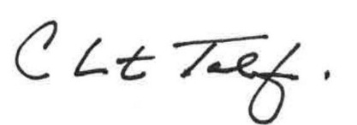
_________________________________
Christoper Taliaferro
29th Ward Alderman

