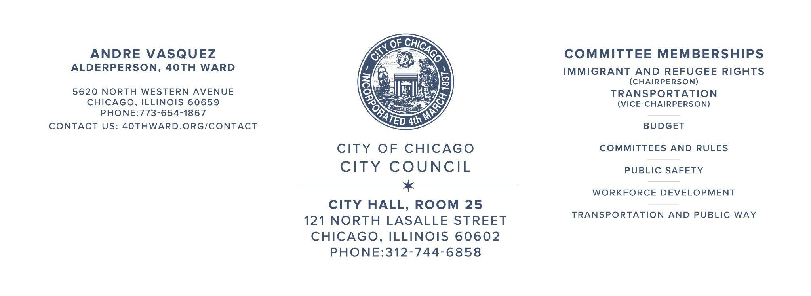
City Council
May 1st, 2024
Committee on Pedestrian and Traffic Safety
Single Direction

BE IT ORDAINED BY THE CITY COUNCIL OF THE CITY OF CHICAGO:
Section 1. That an ordinance heretofore passed by the City Council restricting the movement of vehicular traffic to a single direction on portions of sundry streets, be the same and is hereby amended by striking therefrom, the following:
N. Paulina Street from first alley south of N. Ridge Avenue to W. Thorndale Avenue; Two-way northbound and southbound
and inserting in lieu therefore
Single Direction
N. Paulina Street: N. Paulina Street from first alley south of N. Ridge Avenue to W. Thorndale Avenue, one-way northbound
SECTION 2. This ordinance shall take effect and be in force & upon its passage and publication.

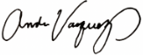
Andre Vasquez
Alderperson, 40th Ward

